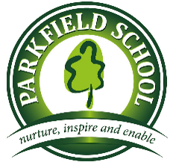

Parkfield Uniform Policy

Policy reviewed by: | Ian Golding
Policy completed: | June 2020
Policy agreed by LGB
Policy Review Date: | June 2021

Rationale
At Parkfield our aim is to engender a sense of school identity and belonging and to encourage high standards of behaviour and appearance in students, whilst creating a sense of equality, ensuring that pupils of all races and backgrounds feel welcome.

All students will be smart, but practical enough to perform their activities in the classroom and other learning environments.

Primary – Reception

- Grey trousers, skirt or pinafore
- Polo shirt with the school logo
- Green Parkfield Sweatshirt
- Black shorts (PE)
- Plimsolls or trainers (PE)
- School book bag
- In the summer months, boys can wear grey shorts and girls can wear the green gingham dress.

Primary - uniform for children in Year 1 - Year 6 consists of:

- Green v-neck jumper or cardigan with the school logo
- Grey trousers (boys and girls) with plain socks, black, grey or white
- Knee-length grey skirt / culottes (girls) with plain socks, black, grey or white and tights, black, grey and flesh coloured.
- White shirt with school tie
- Flat black sensible shoes, no trainers
- In summer months, boys may wear grey shorts and a white polo shirt with the school logo. Girls can wear a green and white gingham dress. A cap or hat will be required in sunny weather.
- Other Items – Green school book bag with logo (Reception, Year 1 and 2) or black rucksack with logo (Years 3-6).

Sports kit:

- Named PE bag
- Black shorts (boys & girls), black skort (girls) and black joggers
- White school t-shirt with logo
- Green school sweatshirt with logo
- Black plimsolls (Reception, Yr1 and Yr2) Trainers (Yr3, Yr4, Yr5 and Yr6)
- Spare socks and underwear for Reception and Year 1

Secondary Uniform

Girls Uniform:
- Parkfield grey blazer with logo (available from Stevensons)
- Black skirt, worn to the knee
- Black school trousers (see later guidance)
- White blouse (see later guidance) or a white shirt and Parkfield tie
- Black shoes (no trainers, see later guidance)
- Optional plain black v neck jumper
- Black tights (plain) or black socks, short or knee length
- A sensible school coat (hoodies will not be allowed)

Boys uniform:
- Parkfield blazer with logo (available from Stevensons)
- Black school trousers (no jeans)
- White shirt
- Parkfield tie (we will review this during 18-19)
- Optional plain black v neck jumper
- Black shoes (no trainers)
- Black socks
- A sensible school coat (hoodies will not be allowed)

PE Uniform
- Black shorts (boys and girls, without design or logos) or skort (girls).
- White thermal base layer (optional).
- White polo shirt (no design or logo is necessary).
- Optional black school hoodie for cold weather (available through the school)
- Black football sports socks.
- Black tracksuit bottom or plain black lycra sports leggings.
- Trainers and appropriate sports footwear.

Other Items:
- Sensible school bag, preferably a rucksack.

The school welcomes children from all backgrounds and faith communities. If there are serious reasons why parents want their child to wear clothes that differ from the school uniform, the school will look sympathetically at such requests.

We request that all items be clearly labeled with the student's name.

Hair must be neat and tidy, with no extreme styles, edges or lines. Hair that is longer than collar length should be tied back at all times.

Students with ear piercings may wear only gold or silver studs. No other piercings are to be worn at any time. Rings, necklaces, bracelets and other jewellery are not to be worn at any time.

Make up is not allowed in until Year 9, at this point it should be discrete. False nails and nail varnish are not permitted.

It is expected that all students maintain pride in their appearance and take good care of themselves and the clothes that constitute their school uniform. If students are wearing a normal collared shirt, we expect students to wear their tie correctly, always fasten their top button and tuck their shirt in.

Students are expected to behave responsibly whenever wearing their uniform to/from/outside of school, remembering that they are representing the school community. We expect students to wear their uniform on the way home from school and do not encourage them changing into and leaving in their own clothes.

Students are welcome to submit honest feedback on the prescribed school uniform and this policy, and if they choose to do so, their voices and opinions will be carefully considered.

It is expected that parents/careers encourage their children to uphold the uniform standards of the school. Parents will be consulted for feedback on the uniform policy of the school, to ensure they fully support it and that their views are taken into consideration.

During periods of very hot weather the school uniform requirements will be reviewed to ensure that students can work effectively.

This policy will be regularly monitored and reviewed by staff and governors.

Appendix 1: Guidance on Secondary School uniform

Specific Guidance
We have looked at a wide range of uniform items available in supermarkets and retailers and we believe that the items shown below are a suitable style and offer good value for Money.
We are also aware that Stevensons offer similar products should you wish to purchase everything in one location.

Girls: trousers
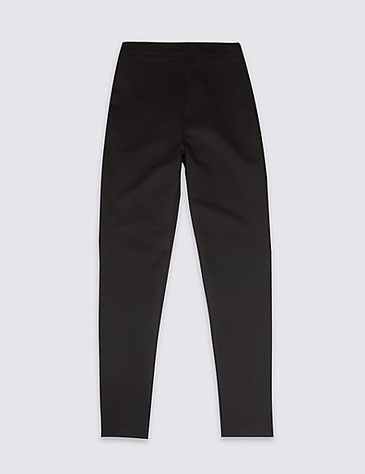 | M&S  Cost: £10.00 – 12.00  Product ID: T761401  Skinny Leg Shape – a tapered leg for our most fashionable cut. Available in a range of different fits.  Composition  - 70% viscose, 26% polyester and 4% elastane  - (exclusive of trimmings)  Care instructions  - Machine washable even at 30º  - Tumble dry

Notes:
- Jeggings, leggings, jeans and any other tight fitting trouser will not be acceptable.

Boys: trousers
Black trousers for boys are relatively simple to source. We ask that they are of a formal design and not too tight fitting. Jeans will not be allowed.

Girls: Blouses
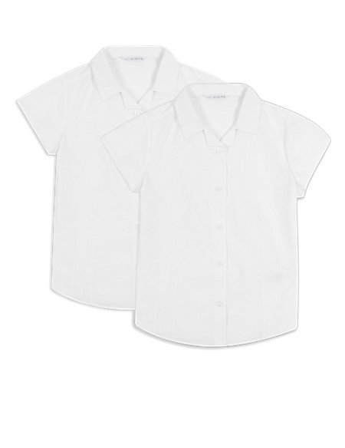 | M&S  Cost: £10.00-12.00 for 2 blouses  Product ID: T765931  - Product Style: Blouse  - Regular fit  - Button through  - Sleeve length: Short sleeve  - Dart detail  Composition  - 65% polyester, 35% cotton  Care instructions  - Machine washable even at 30º  - Tumble dry

Note: Girls are able to choose between wearing the style of blouse above or a normal shirt with the Parkfield tie.
Girls: skirts
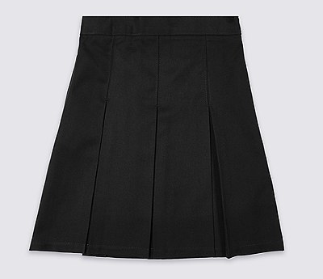 | Shop: M&S  Product name: Girls' Skirt with Permanent Pleats  Item Code: T76/0132  Cost £12.00
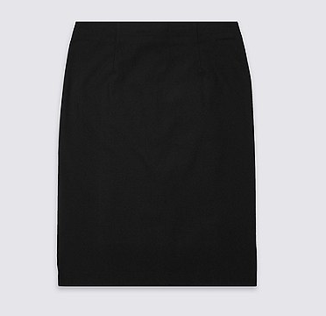 | Shop: M&S  Product name: Senior Girls' Long Pencil Skirt  Item code: T76/0193  Cost £12.00

Note: we would prefer students to wear a heavier style skirt made from polyester and viscose. Jersey style skirts should be avoided.
Skirts must be worn to the knee.

Boys & Girls: Shoes
School shoes need to be comfortable, sturdy, durable and good value for money. They do not need to be fashionable, a practical shoe is much more important.
Shoes that are acceptable | Types of shoes that are not acceptable
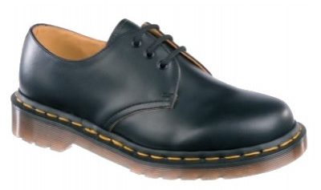 | 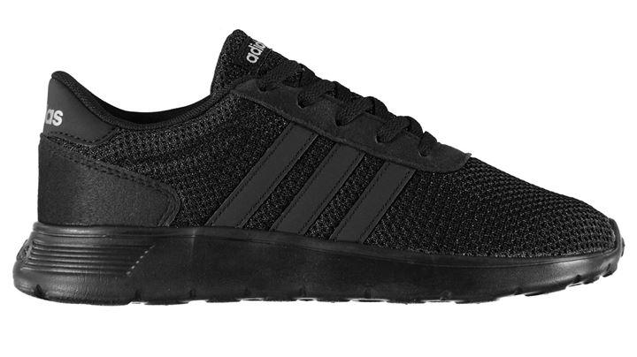  Reason: they are fabric trainers
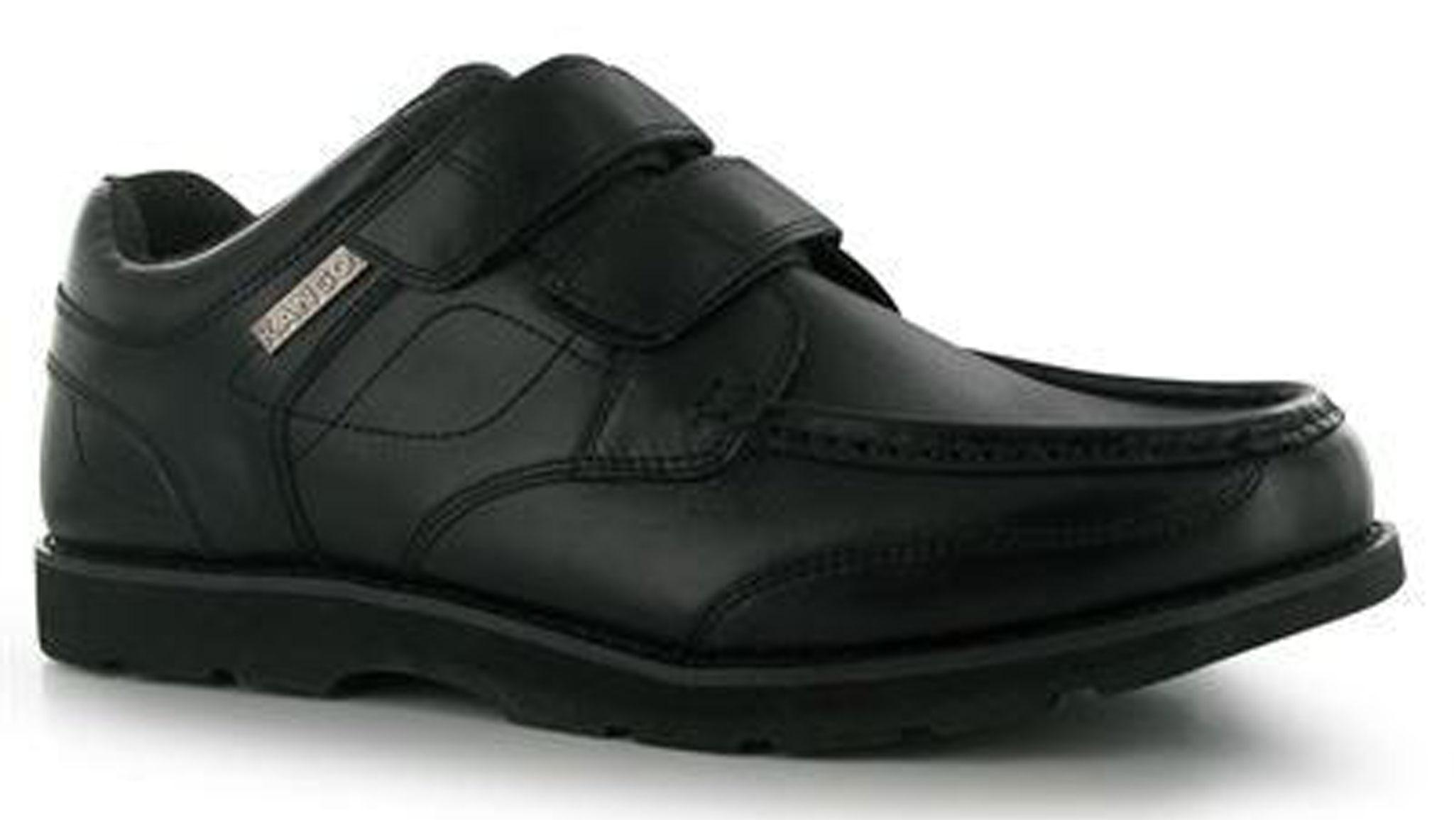 | Reason: they are trainers
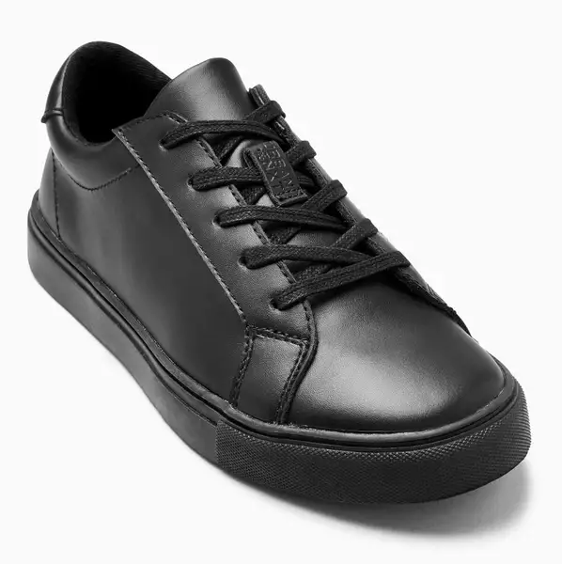 | 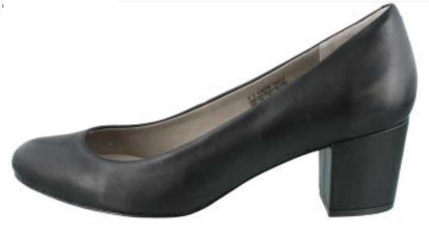  Reason: Heel too high
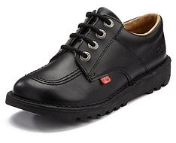 | 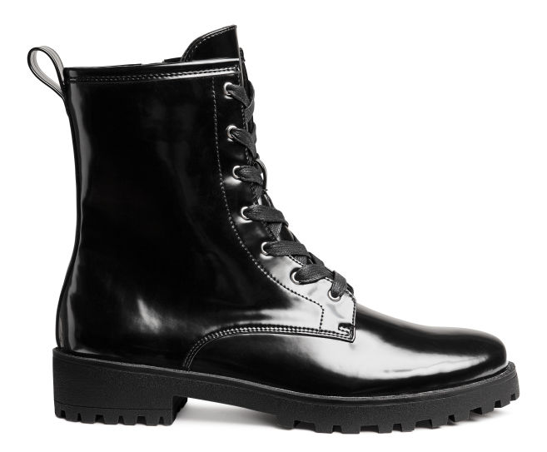  Reason: They are a boot not a shoe
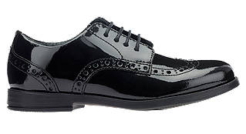 | 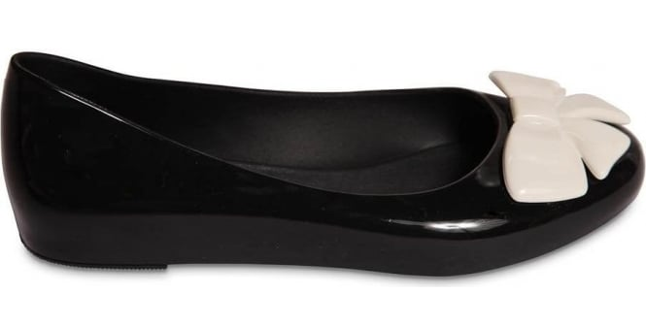  Reason: non-black detail, overly decorative

